Recruit, Develop, Thrive: staffing in library customer services

CSGUK Annual Conference – 21 November 2022
Woburn House, Tavistock Square, London WC1H 9HQ

Programme

09:30 – 10:00 | Registration and Refreshments
10:00 –10:10 | Introductions and Housekeeping - Libby Homer, Chair of CSGUK
10:10 – 10:30 | Icebreaker / Networking: “how did we get here” - delegates share their journeys to working in librarianship / Higher Education with their tables
10:30 – 11:10 | STUDENT CONNECT - A step change in library and university customer service culture at Staffordshire University – Paul Mahoney, Head of Library and Learning Services and Kirstie Brookes, Customer Experience Manager
11:10 – 11:30 | Refreshments and Networking
11:30 – 13:00 | Recruiting Staff –15 minute presentations followed by a panel Q & A.  - Recruiting tomorrow’s leaders today: Teesside’s approach to succession planning – Jackie Oliver  - Accessible recruitment at the University of Westminster – Helen Rimmer and Deepa Rathod  - Students supporting students: creating recruitment opportunities within the library customer services team – Rosie Napier and Sara Wadee, University of Salford  - Have you ever thought about working in a Library? - attracting diverse candidates to Customer Service roles – Mark Laws, University of Manchester  - Value based recruitment for professions allied to medicine and its transferability – Dr Julia H Wood, nurse consultant in practice improvement and dementia care
13:00 – 14:00 | Lunch and Networking
14:00 – 15:00 | Empowering Staff –20 minute presentations  - Engendering a culture of service innovation, improvement and empowerment within Library Customer Support – Teresa Jordan and Andrea Kellett, University of Birmingham  - As you like it … empowering colleagues to flex and create their own – Jade Gilmore and Indu Kuttan, University of Westminster  - Empowering front line staff to support students’ wellbeing – Fiona Pringle, University of St Andrews
15:00 – 15:20 | Refreshments and Networking
15:20 – 16:00 | Hybrid Working Discussion led by CSGUK Resources Group with an introduction from Sally Earney, Cardiff University
16:00 – 16:10 | Closing Remarks – Libby Homer

We will be using Padlet during the conference to capture questions for the presenters as well as feedback on the topics being discussed.
Please access this via bit.ly/CSGUKConf or the QR code below:
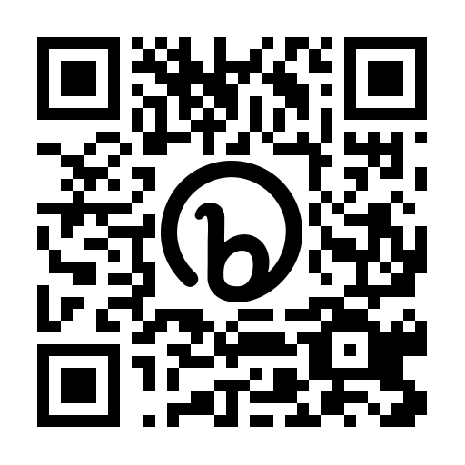

www.customerservicesgroup.co.uk @CSGUKlibraries #CSGUK22

